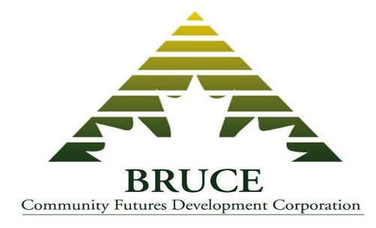
EMPLOYMENT OPPORTUNITY – KINCARDINE, Ontario
OFFICE ADMINISTRATOR – FULL TIME

Reporting to the General Manager, the Office Administrator plays a key role in the Bruce Community Futures Development Corporation (Bruce CFDC), ensuring the day to day handling of all banking, bookkeeping and administrative services relative to the general office and the loan program.
General Administration
- Respond to general information inquiries
- Ensure logistics for Board of Directors meetings
- Order and maintain office supplies
- Handle incoming and outgoing mail, and telephone calls, as required
- Maintain up-to-date policy and procedure documents
- Ensure proper filing and records management
Bookkeeping
- Complete daily input of financial and banking transactions using QuickBooks
- Maintain accounts payable and expense claim files and ensure payments are current
- Complete monthly bank reconciliations and expense account reconciliations
- Provide monthly financial statements with budget variation report
- Payroll administration, filing remittances, coordination of audit documents
Loan Program
- Working closely with the General Manager to ensure required loan data is accurately entered into the Quick Books and TEA programs
- Monitor pre-authorized payments on monthly basis, proceeding with stage 1 collections as required
- Assist in the administration of special projects and contracts
Qualifications
- Minimum of a post-secondary diploma with a minimum of three years of bookkeeping and/or administrative experience. Experience in a Community Futures office is considered a strong asset
- Completion of bookkeeping/accounting training or equivalent experience
- Strong knowledge of office procedures
- Strong computer skills and social media practices
- Strong written and verbal communication skills
- Superior customer service skills
- Work well independently and within a small team environment
- Knowledge of and commitment to the mandate and services of the Bruce CFDC

Bruce CFDC is a non-profit Community Futures corporation funded by FedDev Ontario, dedicated to the economic growth of the Bruce/Grey region.
Applications will be received until 4 p.m. on Friday, February 7, 2020. Respond with a cover letter, resume and quoting Job # 1 to bfisher@bmts.com or mail to Barb Fisher, General Manager, Bruce Community Futures Development Corporation, 233 Broadway Street, Kincardine, Ontario, N2Z 2X9

